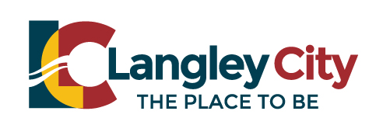
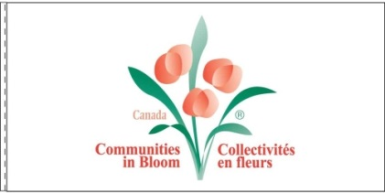

The Communities in Bloom program is a recognition and bloom award program providing a framework for Municipal participants to reinvigorate and enhance their community’s liveability. Using the collaborative power of local government, business & institutions, service clubs and residents, it is this Growing Together that stimulates civic pride and encourages tidiness, beautification and environmental initiatives throughout their area.​The program inspires a transformation process that can have lasting social, environmental and economic benefits.
The CIB program is led by members of the community and involves a significant time commitment to become successful. By submitting this application form you are confirming your willingness to participate in this way. For more information please visit www.bccib.ca.
Expression of Interest for Communities in Bloom Task Group

Name: ____________________________________________________________
Address: __________________________________________________________
Contact info: ______________________________________________________

What do you know about the Communities in Bloom program? _______________________________

What expertise can you bring to the Task Group? ____________________________________________

Have you been involved in Communities in Bloom in the past? ___________________________

How many hours per week/month can you commit to ? __________________________________

Why are you interested in being part of the Task Group?

_____________________________________________________________________________________

